WALLS, FENCES, HEDGES AND TREES

[HISTORY: Adopted 2-21-72, effective 3-13-72. Amended 12-7-98, effective 12-27-98. Revised and restated in its entirety 10-2-06, effective 11-27-06.]

General Provisions

Definitions.
Border fences are fences that separate a person’s property from other people’s properties, either public or private. Non-border fences are wholly internal to an owner’s property, e.g. a fence that separates the front yard from the side yard is a non-border fence.
Chain-link fence is defined as a wire fence woven in a diamond pattern.
Entry feature is an open lattice arbor or trellis arranged over a gate.
Fence height is to be measured on the side of the fence that faces adjoining properties or the street and is measured from the surface of the finished grade to the highest point of the fencing material excluding vertical support posts, e.g., measure to the top of the tallest picket.
Hedge is a row of trees, shrubs or plants grown closely together to form a continuous barrier.
Non-ornamental metal fences are made in whole or in part of chain-link, chicken wire, wire mesh or strands, corrugated metal, sheet metal, barbed wire or other arrangements that are considered unattractive.
Privacy fence is a fence that is less than 50% open (visible through) when viewed perpendicular to the fence.
Shrub is any bushy plant that branches into several stems or trunks at the base and is smaller than a tree.
Yards are defined as follows:
Exterior yard is a yard that is at least partly adjacent to a public area (street, alley, walkway or park). An interior yard is not adjacent to any public areas (streets etc.) but may be adjacent to other private properties.
Front yard is that portion of the property that is to the front of the main building and side yards (exclusive of the side-yard lines).
Rear yard or back yard is that portion of the property that is to the rear of the main building and side yards and is inclusive of the rear side-yard lines.
Side-yard line is the front or rear edge of a side yard. It is a line that runs from a corner of the main building (but not from a corner of an open porch or deck) to the side property line. Side yard lines normally run parallel to the street, but may run parallel to the face of the main building or other angle that is reasonable and aesthetic. Odd shaped lots and houses, large corner porches and other special conditions must be considered individually.
Side yard is a portion of the property that is between a front and rear side-yard line and is inclusive of the front side-yard line and exclusive of the rear side-yard line.
Figure 66-1
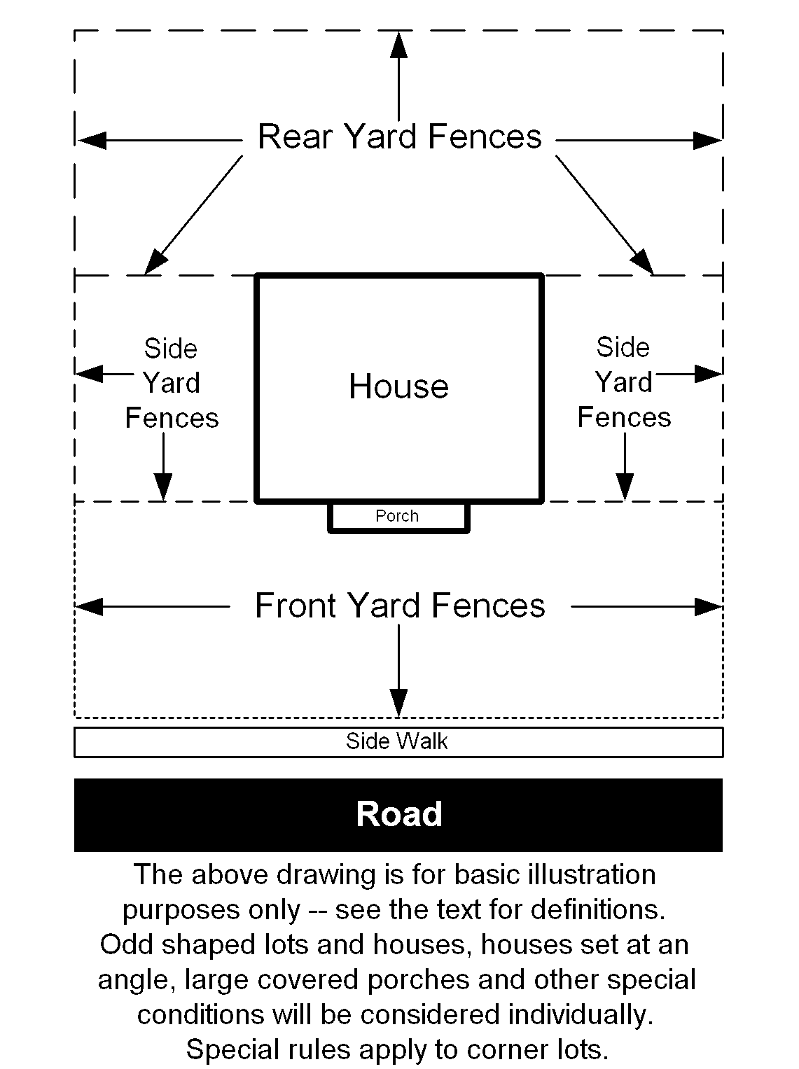

Special exemptions.
The Town Council may grant special exemptions to any of the requirements in this chapter that are not mandated by the county. The Council will give consideration to aesthetics, individual circumstances and to the type and condition of adjacent properties. The Council shall carefully weigh such factors as lot peculiarities and adjacent conditions such as parking lots, trash bins, apartment buildings, highways, railroad tracks, woods, problem animals, high-crime areas, vandalism and poorly maintained properties as possible reasons to grant an exemption. For fences and walls, exemptions may be granted before or after applying for a permit and must be obtained before any wall or fence construction begins.

(Continued next page)

Walls and Fences

Permits for walls and fences.

A town permit is required to erect or replace any fence or wall, except that

A permit is not required to remove a fence.

A permit is not required to erect a non-privacy fence that conforms to all provisions in this chapter and is less than or equal to 48 inches tall.

A permit is not required to erect a conforming entrance feature.

A permit is not required to repair an existing fence as long as the repair maintains essentially the same height, length, style and location as the original fence, and is not otherwise prohibited.

All retaining walls constructed along a sidewalk require a building or construction permit.

A permit application must show all buildings and the height, material and setback of all fences.

Any required town permits are “in addition to” and not “in place of” county permits.

All required town and county permits must be obtained before construction begins.

Setbacks for fences and walls.

Fences and walls must be set back from a public sidewalk or street as specified in Table 66-1 Minimum Fence Setback below. The entire fence or wall (including posts, columns and entry features and any vegetation protruding from the fence) must be at least the given distance from the edge of any public sidewalk or street whichever is further. If a sidewalk is over 5' 2" wide then the setback required from the sidewalk for fences and walls is reduced to zero.

Wherever possible fences should exceed the minimum setback given in the table by 6 inches or more.
Table 66-1 Minimum Fence Setback
Fence Height | Min. setback from most sidewalks | Min. setback from sidewalks over 5' 2" wide | Min. setback from street
Less than 3' | 10" | 0" | 12 feet
3' to 5' | 12" | 0" | 13 feet
Over 5' | 24" | 0" | 14 feet
Min. setback from a street with a speed limit over 26 mph is: |  |  | 15 feet

Fence Orientation.
The more attractive side of a fence must face away from the yard, structure or area that it is intended to enclose or screen.

Fence materials.

Fences must be built of rot resistant materials, e.g. pressure treated lumber, vinyl, brick, stone or metal.

Barbed wire, razor wire and electrified wire fences are prohibited.

Corrugated metal, corrugated fiberglass, and sheet metal fences are prohibited.
Also see Chapter 66(c) in “Front yard fences.”, and Chapter 66(c) in “Exterior rear and side yards.”.

Front yard fences.
Front yard fences must meet the following additional restrictions.

The maximum height for a wall, gate or fence section or combination thereof (excluding vertical support posts) is 4 feet in the front yard.

Privacy fences are limited to 3 feet tall in the front yard. A privacy fence may extend higher only if it is at least 50% open above 3 feet and does not exceed the front yard maximum height limit.

Fence materials.

All non-ornamental metal fences (including chain-link) are prohibited in the front yard.

Slats, rails and pickets greater than 6 inches wide are prohibited in the front yard.

Also see § 66-4 “Fence materials.” above.

Side yard fences.
The maximum height for a wall, gate or fence section or combination thereof (excluding vertical support posts) is 6 feet in an interior side yard. Also see (a) in “Exterior rear and side yards.” below.

Rear yard fences.
The maximum height for a wall, gate or fence section or combination thereof (excluding vertical support posts) is 6 feet in an interior rear yard. Also see (a) in “Exterior rear and side yards.” below.

Exterior rear and side yards.
An exterior yard is a yard that is at least partly adjacent to a public area (street, alley, walkway or park). Exterior rear and side yard fences must meet the following additional restrictions.

The maximum height for a wall, gate or fence section or combination thereof (excluding vertical support posts) is 4 feet in an exterior side yard and 6 feet in an exterior rear yard.

Also see § 66-10 “Fences near an intersection, e.g. corner lots.” below.

Fence Materials.

All non-ornamental metal fences are prohibited in exterior rear and exterior side yards, except for fences that are setback at least 25 feet from public areas or are non-border fences located behind a conforming border fence.

Also see § 66-4 “Fence materials.” above.

Gates and entry features.

Gates may not swing outward onto any public road, sidewalk or public passageway.

Entry features in border fences may not exceed 8' in height, 3' in depth or 5' in width.

Entry features in non-border fences may not exceed 10' in height, 6' in depth, or 8' in width.

Fences near an intersection, e.g. corner lots.

Visibility at corners and intersections may not be obstructed for drivers and pedestrians.

Clear sight triangle.
Figure 66-2 Clear Sight Triangle
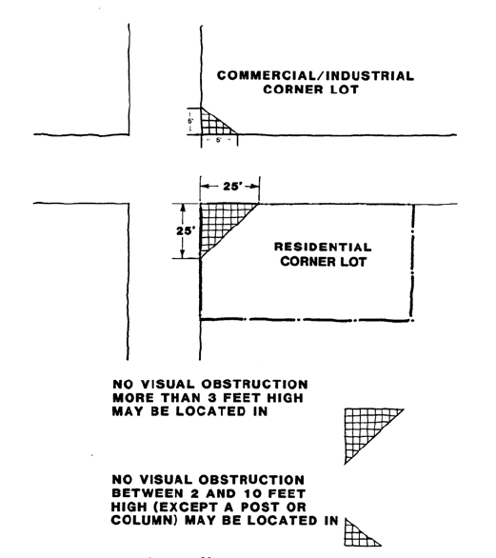
County law dictates that on a residential corner lot, no visual obstruction more than three (3) feet high (above the curb level) shall be located within the triangle formed by the intersection of the street lines and points on the street lines twenty-five (25) feet from the intersection. (See Figure 66-2 Clear Sight Triangle)
County law dictates that on a commercial or industrial corner lot, no building or other visual obstruction (except a post or column) between two (2) and ten (10) feet high (above the curb level) shall be located within the triangle formed by the intersection of the street lines and points on the street lines five (5) feet from the intersection.
Fences and walls that adhere to “Table 66-1 Minimum Fence Setback” above are outside of the Clear Sight Triangle, as is any fence or object, which is setback from both streets such that the sum of the setbacks is at least 25 feet.

Pool enclosure fences.
All pools (except wading pools of 24 inches or less) must be completely and continuously enclosed by a permanent durable wall, fence or barrier, which

is at least 6 feet tall (as required by the county), and

has no opening larger than 3 inches in any dimension except for doors and gates, and

has self-closing, self-latching gates that swing away from the pool, and

obeys all town, county and state regulations.

Screening for refuse containers and dumpsters.
See § 36-9(d) for fences around commercial trash containers.

Temporary construction fences.
The Town Administrator may allow temporary fences for up to one full year not in strict conformity with this chapter at construction or excavation work sites in order to protect the safety of the public and of the workers at the site. No barbed or razor wire shall be allowed.

Fences, walls and gates must be kept in good repair.
All fences, gates, retaining walls and parts thereof must be maintained in a structurally safe and sound manner and in good repair. Fence and wall sections must be kept firm and upright. Rusted areas must be replaced or painted. Missing or decayed parts must be repaired or replaced. Peeling paint must be replaced. See ARTICLE IV Violations § 66-1 and § 66-2 for violation procedures and penalties.

Other law.

Fences must meet all design and construction specifications of the building code of the Town of Riverdale Park and Prince George's County, Maryland, and The Maryland-National Capital Park and Planning Commission as well as the Ordinance Code of the Town of Riverdale Park.

Fences located in the Mixed-Use Town Center (M-UTC) Zone must meet the requirements specified in the Town of Riverdale Park Mixed-Use Town Center Zone Development Plan.

Grandfather clause for fences.

All fences legally existing as of November 27, 2006, which do not comply with any part of this chapter are deemed non-conforming use.

All front yard fences erected after November 27, 2006 that are intended to replace a non-conforming use fence must conform to the requirements of this section. In particular, front yard chain-link fences may not be replaced with a chain-link fence.

A fence deemed to be a non-conforming use, which has been removed or destroyed through no fault of the owner and due to circumstances beyond the control of the owner (except for natural aging), may be replaced or repaired in a manner substantially identical in all materials, height, length and location to the fence so removed or destroyed provided it is repaired or replaced within 180 days from the date of the removal or damage.

Nothing contained in this section shall be construed to prohibit the maintenance and repair of a non-conforming fence so long as the fence is not changed in character and all repairs are made with materials substantially the same as the materials requiring maintenance or repair.

Reserved.

(Continued next page)

Hedges, Shrubbery and Trees

Height of hedges and shrubbery.

Maximum Height. A border hedge is a hedge that separates a person’s property from other properties, either public or private and is located within 4 feet of that other property, public sidewalk or right of way or located within 16 feet of a street. The maximum height for a border hedge is 4 feet in the front yard, 6 feet in the side yard and 8 feet in the rear yard.

Additional height restriction at front of lot. The maximum height for a hedge that is within 16 feet of the front street is 3 feet.

Setback of hedges, shrubbery and trees.

Where there is no public sidewalk along a street, a clear pathway of at least 5 feet wide must be maintained parallel to and within 12 feet of a street.

New trees must be located so that when full grown the tree trunk will be at least 2 feet from any public walkway or street.

All parts of a hedge must be set back from a street at least 13'. This setback is increased to 14 feet, if the street’s speed limit is over 26 mph.

No tree or shrub may overhang a public sidewalk or street in a manner that impedes the public. Vegetation that overhangs a public walkway must be kept at least 7 feet above the walkway. Vegetation that overhangs a street must be kept at least 10 feet above the street.

Setback from walkways. Clear walking areas require shoulder and head room. Hedges, shrubbery and tree limbs or parts thereof must be setback from public walkways through a height of 7 feet as specified in Table 66-2 (below). An exception is made for sidewalks that are over 5' 2" wide, which have a reduced minimum setback (see table).
Table 66-2 Minimum Setback from walkways through a height of 7 feet
Plant Height | Min. setback from most sidewalks | Min. setback from sidewalks over 5' 2" wide
10" to 30" | 8" | 4"
30" to 5' | 14" | 4"
Over 5' | 26" | 8"

Grandfather clause for vegetation.
Any vegetation legally existing as of November 27, 2006, which does not comply with the above setback or maximum height limits and which would be extensively damaged or die if trimmed back to those limits need only be trimmed as far as is possible providing the plant does not continue to overhang a public sidewalk.

Visibility at Intersections.
Vegetation may not obstruct visibility at corners and intersections for drivers and pedestrians. County law dictates that on a corner lot, no visual obstruction more than 3 feet high (above the curb level) shall be located within a clear sight triangle. See (b) “Clear Sight Triangle” above for details. Vegetation that is setback at least 12' 6" from both streets is clear of the sight triangle.

Reserved.

Violations

Procedure for violations.
Whenever a provision of this chapter is violated, then

The town shall notify the owner or custodian of the property that they must remedy the condition within

15 days after receipt of notice—for violations involving trees, hedges or shrubbery.

45 days after receipt of notice—for violations involving walls or fences, or

Immediately, if the Mayor and Town Administrator determine that a significantly dangerous condition exists.

Extension. If the Mayor or Town Administrator finds it appropriate they may grant from 0 to 45 additional days for a condition to be remedied.

Upon failure to comply within the given time limit or extension, then

The owner or custodian will be subject to the penalties set forth in § 66-6, and

The town may arrange for the work to be done, the cost of which shall be assessed against the owner or custodian of the property, such costs to become a lien against the property and collectible as other municipal taxes are collected.

In the event that the owner or custodian cannot be successfully notified of such condition, the town reserves the right to correct such condition, the cost of which shall be assessed against the owner or custodian.

Appeal. If any person interested in the property feels aggrieved by the application of this provision to his or her particular case, they may appeal to the Mayor and Council where they shall be given a hearing. If the Mayor and Council find that an exceptional condition exists then the Mayor and Council may determine what is reasonable and safe for the particular situation and will specify by what date the person must conform to the council's decision and what if any fine or penalty is due.
Furthermore, any person aggrieved by the council's decision who was a party to the proceeding may appeal to the Circuit Court which shall have the power to affirm the decision of the municipality or, if the decision is not in accordance with law, to remand the matter or to modify or reverse the decision.

Violation penalties.
Violations of the provisions of this chapter are declared to be municipal infractions, the penalty for which, unless specified otherwise, is one hundred dollars ($100) for each offense. If no appeal is pending, then every 30 days that the violation continues past the date of the initial fine shall constitute a separate offence with an additional $100 penalty.
[End of Chapter 66]

